**FLAT FLOOR & FULL WALL SLIDE-OUTS**

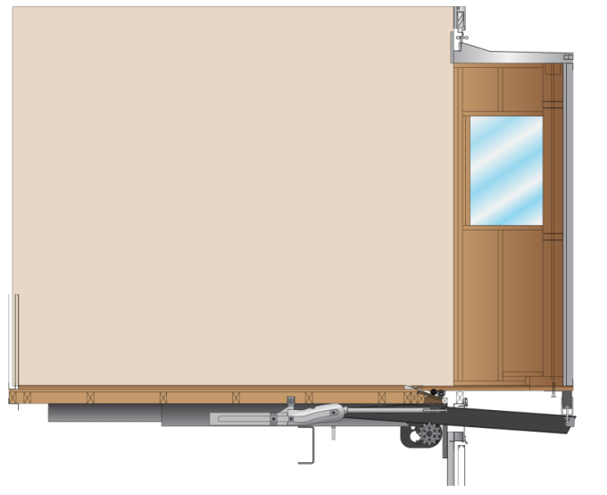

**2 Types of Flat Floor Slide-Outs**

1. Full Wall – uses two motors with brakes and **encoders**, four cog wheels, 4 actuating arms, and a KIB controller
2. Basic – Uses one motor with a brake, two cog wheels, two actuating arms, and a C-Storm controller

All Flat Floor Slide-Outs

* Uses Rack and Pinion System
* Ignition must be turned **OFF** and Parking Brake **SET** to operate
* Uses a ramp to lower slide-out to same level as the main floor

**Retracting the Slide-Out Manually**

* Manual Retraction: **Method #1** – Loosen all Trantorque bushings and push slide-out in by hand, Re-torque Bushings to 175 ft lbs

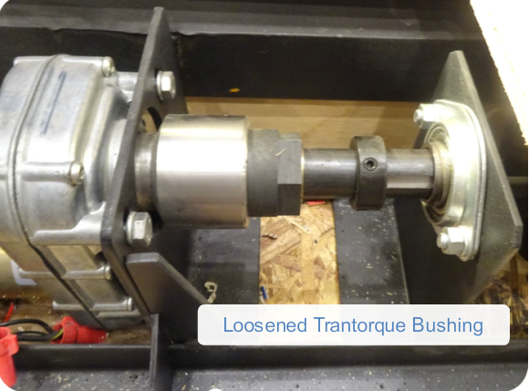

* Manual Retraction: **Method # 2**  - Remove the rubber boot and brake from the motor(s), use a screw gun with a 5/8” socket to turn gear reduction nut. (Alternate between motors or have a helper and 2nd screw gun and operate both motors on Full Wall)

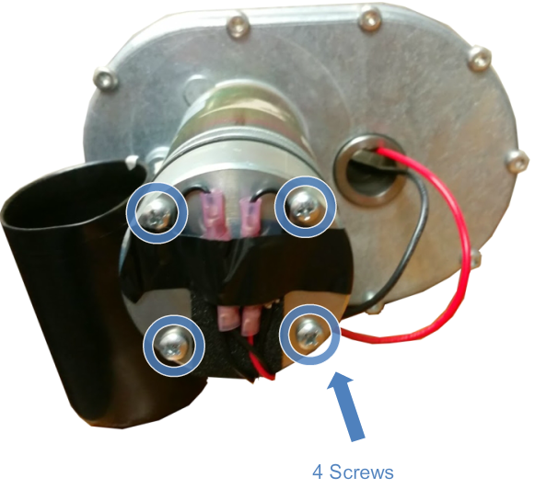

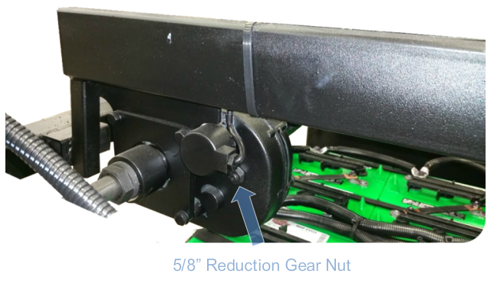

**Squaring a Flat Floor (NON- Full Wall Slide-Out)**

* If a Trantorque bushing slips it will cause the room to bind or extend/retract unequally
* If a Trantorque bushing slips on a Full Wall slide out, do this, then set the “Soft Limits”

1. Extend the slide-out to just before full extension and measure from the “Z” trim to the slide-out trim.
2. Loosen the Trantorque bushing(s) and manually position the slide-out so that both ends are equal.
3. Torque the Trantorque bushing to 175 ft lbs
4. Using a marker, draw a line across the bushing and shaft
5. Run the slide-out several times and verify the bushing is not slipping on the shaft

**Adjusting the Reveal Front to Rear**

* Over time the slide-out may drift forward or backward out of center
* This adjustment affects the slide-out in the “In” or “Retracted Position”

1. Check the reveal of the slide-out trim in relation to the “Z” trim

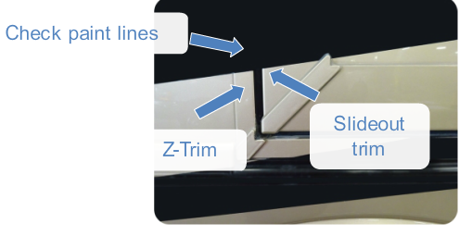

1. Fully extend the slide-out
2. Use a grease pencil to mark your starting point on the activating tubes

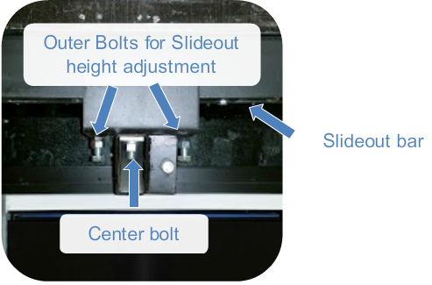

1. Loosen the nut in the center of the activating tubes
2. Move the tube in the opposite direction you want the slide-out to move
3. Move all tubes the same amount and re-tighten the nuts after each step
4. Extend and retract the slide-out several times to ensure the adjustments are correct

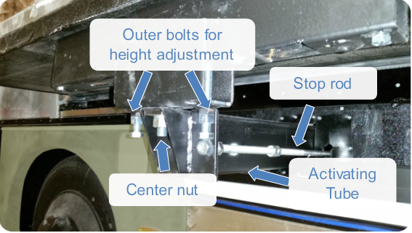

**Adjusting the Reveal Up and Down**

* Over time the Slide-out may settle and become too high or too low
* This adjustment affects the slide-out in the “In” or “Retracted Position”

1. Watch paint lines and reveal before, during and after adjustment
2. Loosen the jam nuts on the outer bolts Loosen the center bolt of the activating tube
3. Tighten the outer bolts to raise the slide-out
4. Loosen the outer bolts to lower the slide-out
5. Re-tighten jam nuts and center bolt
6. Run slide-out several times to ensure correct adjustment

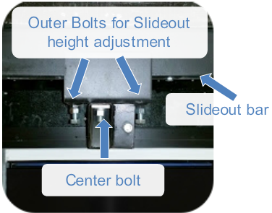

**Adjusting the “Saddle” and “Stop Rod”**

* Needed if the slide-out is not sealing to the interior wall
* The “Saddle” adjustment affects the top of the slide-out
* The “Stop Rod” adjustment affects the bottom of the slide-out
* This adjustment affects the slide-out in the “out” or “Extended” position
* This is accessed through the baggage compartment directly under each actuating arm

1. Extend the slide-out half way
2. To tilt the top of the slide-out closer to the interior wall adjust the “Saddle” bolt **up**
3. To tilt the top of the slide-out farther away from the interior wall adjust the “Saddle” bolt **down**
4. To adjust the bottom of the slide-out adjust the “Stop Rod” in or out accordingly

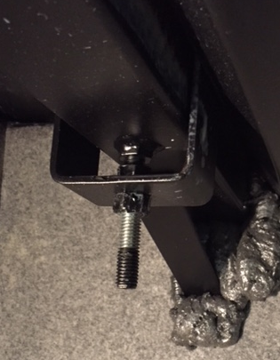

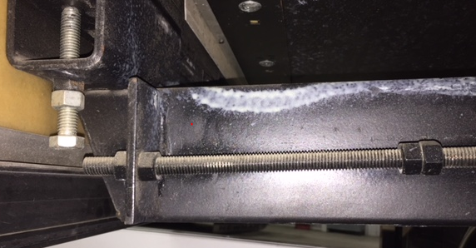

**Replacing the Motor**

1. Level the coach on the jacks
2. Jack up the slide-out just enough to take the weight off the cog wheel and shaft
3. Loosen the Trantorque bushing and set screws on the cog wheel, and bearing retainer

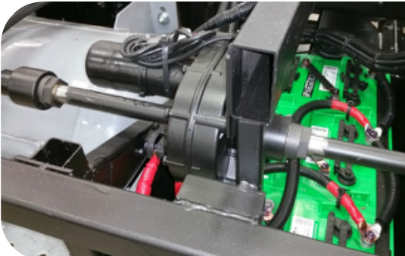

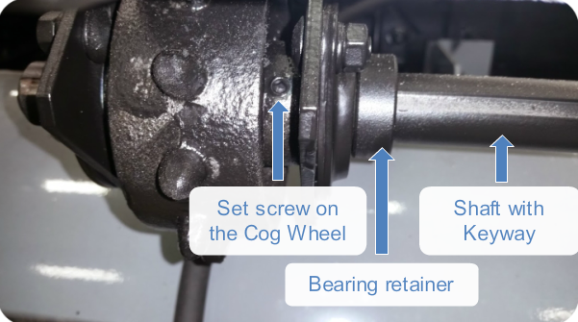

1. Slide the cog wheel through the shaft to allow shaft to be disassembled
2. Loosen the 4 bolts and slide the motor off the shaft
3. Reverse the procedure to reassemble
4. Be sure to use “Blue” Loctite on the motor bolts and torque to 33 ft lbs
5. Ensure the shaft is clean, and torque the Trantorque bushing to 175 ft lbs

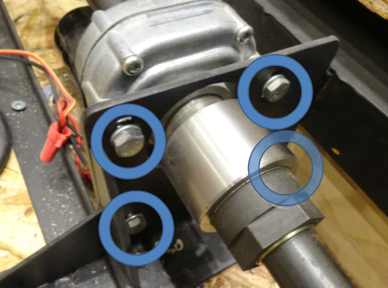

**Replacing the Rollers**

* **DO NOT** use this procedure on a Full Wall Slide out. (It is too heavy to use these blocks)

1. Extend the slide-out all the way
2. Place blocks on the roof of the slide-out

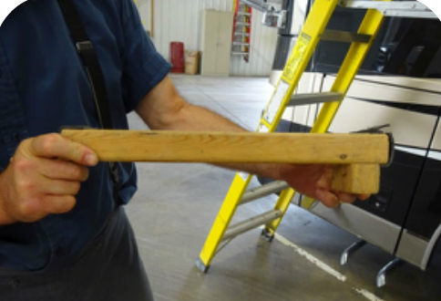 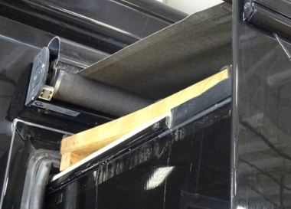

1. Retract the slide-out, making sure the blocks are not gouging the roof and contacting the “Z” trim correctly. This will tilt the slide-out and allow for access to the rollers
2. Install a block under the slide-out for safety and replace the roller

* The same concept applies for Full Wall slide-outs. With the slide-out approximately ½ way in and the help of 4 or 5 people, manually tilt the slide-out up, by pushing on the top of the slide-out, from inside the coach. Then place blocks under it, to hold it up while removing the rollers.